PingOne Multi-Environment Architecture Strategy
Technical Blueprint for Provisioning N+ Environments from a Master Baseline
- Target Systems: PingOne, Microsoft Entra ID, SCIM 2.0, Terraform
- Scope: Control & Data Plane Alignment

1. Executive Summary & Core Architectural Finding
Establishing and maintaining 10+ synchronized PingOne environments derived from a single "master" baseline requires a strict architectural boundary. In enterprise identity platforms, Configuration (Control Plane) and User Identity Data (Data Plane) operate under fundamentally different boundary, security, and lifecycle rules.
Attempting to mirror both configuration and live user data using a single mechanism (e.g., pure UI replication or peer-to-peer data syncing) is an anti-pattern. It leads to circular synchronization loops, severe PII exposure in non-prod tiers, and rapid exhaustion of API rate limits.
The Recommended Enterprise Standard (Hybrid Model):
- Control Plane (Configurations, Schemas, Policies): Synchronized via Infrastructure as Code (IaC) / Terraform & GitOps from a Git repository serving as the true master configuration.
- Data Plane (User Identities, Groups, Lifecycle): Synchronized via a strict Hub-and-Spoke Outbound SCIM 2.0 Provisioning Engine flowing strictly one-way from the Master Environment to Spoke Environments.
2. Architectural Matrix: What Gets Synchronized How
Component Domain | Element / Feature | Mechanism | Operational Behavior
Control Plane | Custom Schema Attributes | Terraform (IaC) | Declares costCenter, employeeNumber, etc. across all 10 envs before users arrive.
Control Plane | OIDC / SAML Applications | Terraform (IaC) | Standardizes grant types, PKCE, scopes, and attribute mappings across targets.
Control Plane | Authentication & MFA Policies | Terraform (IaC) | Enforces identical password rules, MFA prompts, and risk engine thresholds.
Control Plane | Branding & Templates | Terraform (IaC) | Deploys custom login themes, logos, and system notifications.
Data Plane | User Profiles & Extensions | Outbound SCIM 2.0 | Pushes user creations, updates, and custom attribute values near real-time.
Data Plane | Account Status & Lifecycle | Outbound SCIM 2.0 | Sends PATCH requests to set active=false upon deactivation/deprovisioning.
Data Plane | Groups & Memberships | Outbound SCIM 2.0 | Replicates security group memberships for entitlement assignment.

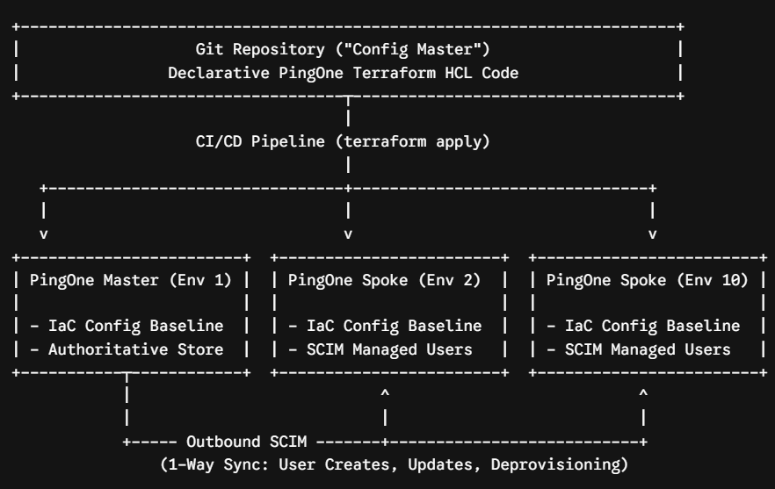

4. Technical Setup & Implementation Guide
Phase 1: Control Plane Deployment (Terraform HCL)
The following modular Terraform code loops over all 10 PingOne Environment UUIDs using for_each to deploy an identical baseline of custom schema attributes, populations, and OIDC applications.

# terraform.tfvars
pingone_client_id = "00000000-0000-0000-0000-000000000000"
pingone_client_secret = "your-worker-app-client-secret"
pingone_environment_id = "your-admin-worker-environment-id"
pingone_region_code = "NA"

target_environment_ids = [
"11111111-1111-1111-1111-111111111111", # Master / Env 1
"22222222-2222-2222-2222-222222222222", # Spoke / Env 2
"33333333-3333-3333-3333-333333333333", # Spoke / Env 3
"44444444-4444-4444-4444-444444444444",
"55555555-5555-5555-5555-555555555555",
"66666666-6666-6666-6666-666666666666",
"77777777-7777-7777-7777-777777777777",
"88888888-8888-8888-8888-888888888888",
"99999999-9999-9999-9999-999999999999",
"aaaaaaaa-aaaa-aaaa-aaaa-aaaaaaaaaaaa" # Spoke / Env 10
]

# main.tf (Root Loop)
module "pingone_baseline_environments" {
source = "./modules/pingone_baseline"
for_each = toset(var.target_environment_ids)
target_environment_id = each.value
}

# ./modules/pingone_baseline/main.tf (Module Definition)
data "pingone_schema" "user_schema" {
environment_id = var.target_environment_id
name = "User"
}

resource "pingone_schema_attribute" "cost_center" {
environment_id = var.target_environment_id
schema_id = data.pingone_schema.user_schema.id
name = "costCenter"
display_name = "Cost Center"
type = "STRING"
user_modifiable = false
}

resource "pingone_population" "standard_users" {
environment_id = var.target_environment_id
name = "Standard Users Population"
}

resource "pingone_application" "portal_app" {
environment_id = var.target_environment_id
name = "Standard Portal App"
type = "SINGLE_PAGE_APP"
enabled = true

oidc_options {
type = "SINGLE_PAGE_APP"
grant_types = ["AUTHORIZATION_CODE"]
response_types = ["CODE"]
token_endpoint_auth_method = "NONE"
redirect_uris = ["https://portal.company.com/auth/callback"]
pkce_enforcement = "REQUIRED"
}
}

Phase 2: Data Plane Provisioning (PingOne Outbound SCIM Setup)
- Configure Spoke Worker Apps (Envs 2–10): Create a Worker Application in each Spoke with the Identity Data Admin role. Record the Client ID, Client Secret, and SCIM endpoint URL ([https://scim-api.pingone.com/environments/](https://scim-api.pingone.com/environments/){SPOKE_ENV_ID}/v2).
- Establish SCIM Connections in Master (Env 1): Navigate to Integrations > Provisioning > Connections in Master. Add a SCIM Outbound connection configured with OAuth 2 Client Credentials pointing to the Spoke SCIM URL.
- URL Encoding Rule: When calling specific PingOne SCIM URN endpoints directly via API, URL-encode colons to %3A (e.g., .../v2/Schemas/urn%3Aietf%3Aparams%3Ascim%3Aschemas%3Acore%3A2.0%3AUser).
- Define Rules & Attribute Mappings: Under Provisioning > Rules, map user profile fields (userName, email, active, costCenter) to trigger automated creates, updates, and deactivations.
Critical Operational Safeguards:
- Strict One-Way Data Flow: Never construct bi-directional SCIM flows (Spoke $→$ Master). This creates circular synchronization loops that lock APIs and exhaust rate limits.
- Passwords Are Not Replicated: SCIM 2.0 specifications do not export raw password hashes. Users in Spoke environments must utilize Federated SSO or reset passwords upon account creation.
- Schema Precedence: Always execute terraform apply to deploy custom attributes in Spokes before enabling SCIM provisioning rules that reference those attributes.
5. Entra ID Integration Strategy & Discussion Guide
When evaluating Microsoft Entra ID as the primary Identity Provider (IdP) with PingOne acting as the Service Provider (SP), align your team on the following key questions:
- Source of Truth Boundary: Will Entra ID push users directly into the PingOne Master environment (letting PingOne replicate downstream), or will Entra ID manage SCIM connections to all 10 PingOne environments independently?
- Attribute Unique Key: Will UserPrincipalName or mail serve as the immutable userName key across systems?
- Deprovisioning Behavior: Should unassigning a user in Entra ID initiate a soft-delete (active=false) or a permanent hard-delete in PingOne?
- Token Secrets Lifecycle: How will long-lived SCIM Bearer Tokens and Worker App Client Secrets be rotated and stored securely (e.g., Azure Key Vault / HashiCorp Vault)?

Note : Configure Data Provisioning via Outbound SCIM
- Prepare Destination Envs (Spokes 2–10):
  - Create a Worker Application in each destination environment with the Identity Data Admin role.
  - Obtain the OAuth Token Endpoint, Client ID, Client Secret, and SCIM Base URL ([https://scim-api.pingone.com/environments/](https://scim-api.pingone.com/environments/){spokeEnvId}/v2).
- Setup SCIM Outbound in Hub (Env 1):
  - Go to Integrations > Provisioning > New Connection > SCIM Outbound.
  - Choose OAuth 2 Client Credentials, input the Spoke environment worker app credentials, and complete Test Connection.
- Set Provisioning Rules:
  - Enable Allow Users to be Created, Updated, Disabled, and Deprovisioned.
  - Select groups or create a User Filter Rule to map which users flow to which spoke environments.
  - Repeat this setup for all 9 spoke connections.
3. Pros and Cons of This Approach
Pros
- Zero Configuration Drift: Any manual changes made in a spoke UI are flagged and restored back to baseline on the next terraform apply run.
- Automated Identity Lifecycle: User changes made in the Hub push to spokes within seconds via SCIM.
- Audit Compliance & Visibility: Git commit history provides a complete audit trail of who changed what policy or app definition across all environments.
- No Custom Code Maintenance: Relies entirely on native PingOne SCIM APIs and the official HashiCorp-verified PingOne Terraform provider.
Cons
- Initial Setup Overhead: Writing and modularizing Terraform HCL code requires upfront effort compared to clicking in the Admin Console.
- SCIM Connection Scaling: The Hub environment must maintain 9 individual Outbound SCIM connections, requiring token rotation management.
- Strict Dependency Order: Schema attributes must be created via Terraform in spokes before SCIM tries to sync users containing those attributes.
4. Key Limitations & Critical Technical Safeguards
[!WARNING]
Strict One-Way Data Flow (No Multi-Master):
SCIM provisioning must strictly run Hub $→$ Spokes. Never configure SCIM back from a Spoke to the Hub, or between Spokes, as this creates infinite replication loops that will lock out APIs and breach rate limits.
- Passwords Are Not Replicated: SCIM protocol specifications do not export raw password hashes. Users created in spokes via SCIM will either need federated SSO set up or will receive an automated invitation link to set a password in the spoke environment.
- Environment-Specific Secrets: Client Secrets for applications, SAML Certificate keys, and OAuth Redirect URIs must remain unique per environment. These must be managed as dynamic variables in Terraform.
- API Rate Limiting: When syncing bulk users (e.g., initial seed of 10,000+ accounts), batch the SCIM provisioning rules to avoid hitting PingOne API limits across 9 simultaneous outbound targets.

